AWS SDK Boto3

Boto3 is the AWS SDK (Software Development Kit) for Python. It enables you to create, use, update, and delete AWS resources with your Python scripts. It is basically a Python library.

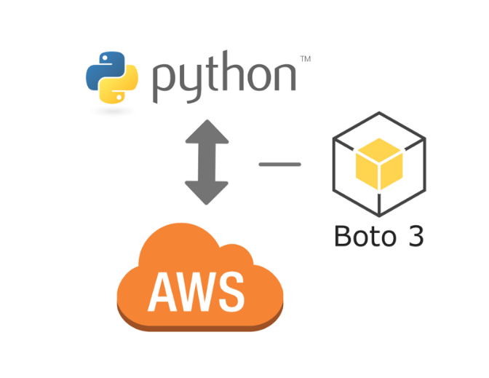

### **Installation and Configuration**

To install Boto3, open your terminal (Commands below works also for Command Prompt-Windows), and type the code below for the latest version.

pip install boto3

**Note:** If you are using Python3, try pip3 install boto3 instead. You must have pip/pip3 installed to be able to run the command.

To be able to use Boto3, you need to set up your credentials. Because we want to access to AWS resources, we have to authenticate the program. This process is made by the AWS CLI. If you have AWS CLI installed and configured you don't need to do anything. You can check and configure your credentials with:

aws configure

If you don't have it installed, please check AWS Command Line Interface - AWS CLI for installation and configuration.

### **Using Boto3**

Now that we have Boto3 installed and configured, let's write a simple script interacting with AWS S3.

Open your Python interpreter and write the code below. To be able to use Boto3, first you need to import it (import boto3), then you can type other commands regarding it.

import boto3

# Use Amazon S3

s3 = boto3.resource('s3')

# Print out all bucket names

for bucket in s3.buckets.all():

print(bucket.name)

The script above prints your buckets in S3. If you have any buckets you should be able to see them. If you don't please create an S3 bucket and try again. Then we can use the same bucket also for the sample below.

After printing our buckets, let's try to upload a file to the S3 bucket.

For the example below, you need an S3 bucket and a file in your working directory (test.jpg for this case) to upload. If you have your bucket ready and put your test file in your working directory, type the code below.

**Note:** Use your own bucket name for my-bucket, and your own test file name for test.jpg

import boto3

# Use Amazon S3

s3 = boto3.resource('s3')

# Upload a new file

data = open('test.jpg', 'rb')

s3.Bucket('my-bucket').put_object(Key='test.jpg', Body=data)